BULLHORN

ACCESSING CANDIDATE DATABASE
To access the candidate database:

- Click on the “Menu” icon in the upper left corner

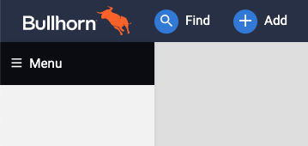

- Click on “Candidates”

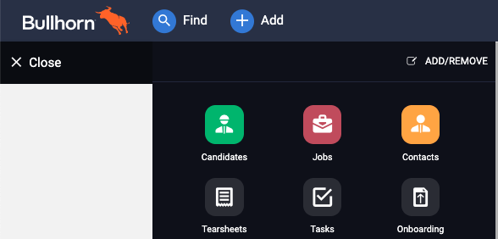

BULLHORN CANDIDATE SEARCH
From the Candidates list view in Bullhorn you are able to source candidates within our database by using the search feature. There are 2 types of searches:

- Basic
- Advanced

To access your Bullhorn Search feature:

- Launch your Candidates List view from the hamburger menu function in the upper left corner.
- Once your Candidates List view is displayed on your screen, you can launch the Search function by clicking your mouse into the Search field within your Candidate Navigation Pane.
- Your display will either show the Basic or Advanced view search feature. To Determine which view you are displaying, the link on the right side of the keyword search field will show one of the following:
  - Switch to Basic (You are currently in Advanced view)
  - Switch to Advanced (You are in Basic view)

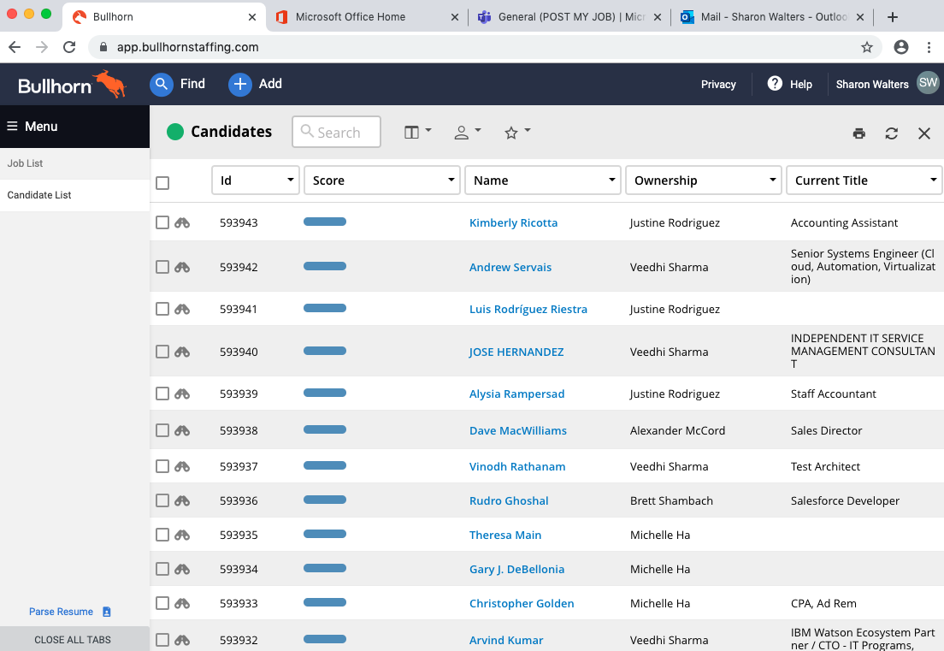

ADVANCED SEARCH NAVIGATION
In the Advanced Search view there are the following sections:

- Keyword Entry
- Magnifying Glass
- Suggested Keywords
- Additional Criteria

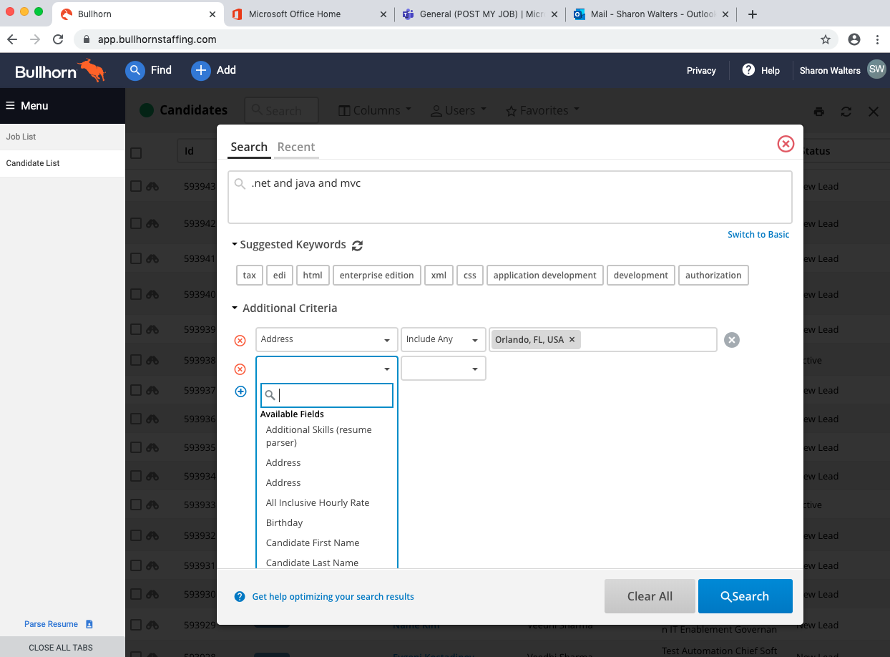

KEYWORD ENTRY
In the Keyword Entry field you will notice there’s a magnifying glass. When you hover your mouse over the magnifying glass the magnifying glass will display exactly where our keywords are looking. You want to become very familiar with where those keywords are looking, because if there are any other values not identified in this location, we will want to add additional criteria.

In the Keyword Entry field you can enter your Boolean structured keyword search criteria, which allows us to use Boolean search operators:
- AND
- OR
- NOT
- * (Allows you to search off the base of a keyword)
- “xx”
- (xx)

Our operators do not need to be capitalized but it does help us to identify which ones are our operators in our Boolean string.

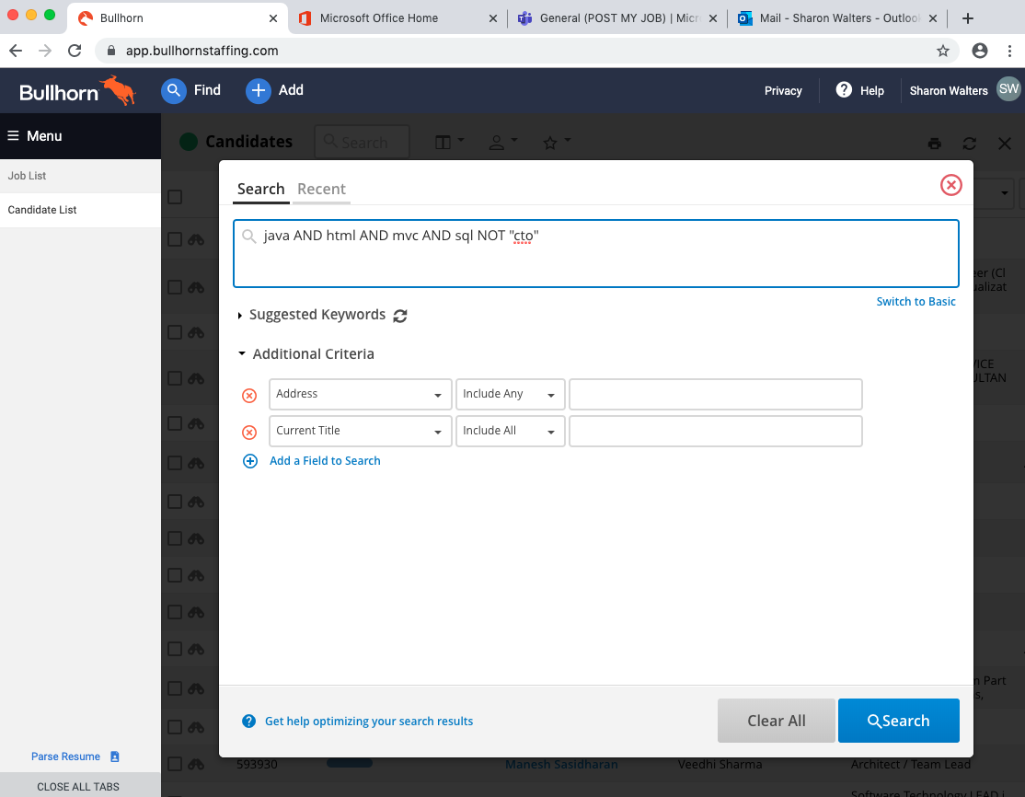

MAGNIFYING GLASS
The Magnifying Glass is defaulted to search for keywords in the following fields in the Candidate Results List:

- ID  - Name  - Current Company  - Notice Required | - Current Title  - Resume  - File Attachments

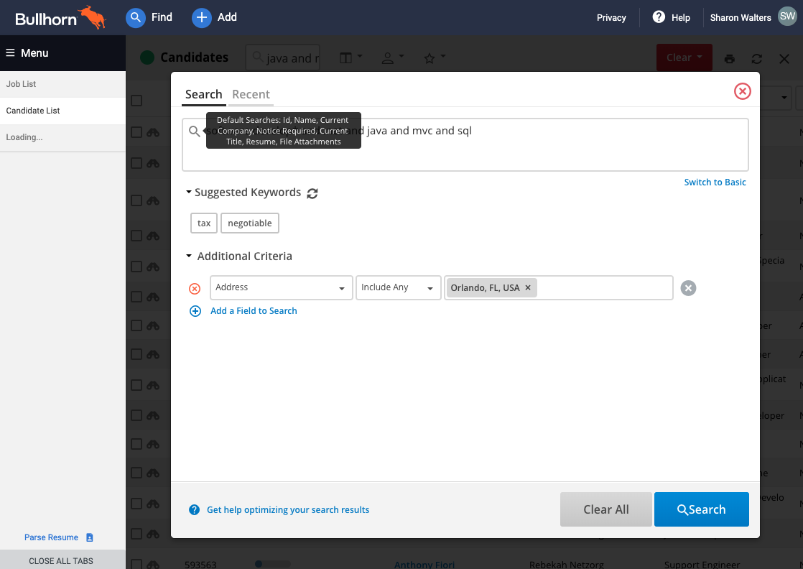

SUGGESTED KEYWORDS
The feature called Suggested keywords feature will populate additional keywords associated with the keywords you have already entered. This allows novice users to develop their search skills and allows expert users a quick way to enter keywords quickly.

You can click on the Refresh icon to continue refining your results as you continue to narrow or widen your Boolean search.

ADDITIONAL SEARCH CRITERIA
The Additional Search Criteria section allows you to select additional parameters to narrow your search results. A popular choice is the Address filter which allows you to narrow down to a location or within a radius.

To add a filter:
- Click on Add a Field to Search
- Click on the dropdown menu and click on the desired filter you would like to select

To remove a filter:
- Click on icon with the red x in a circle

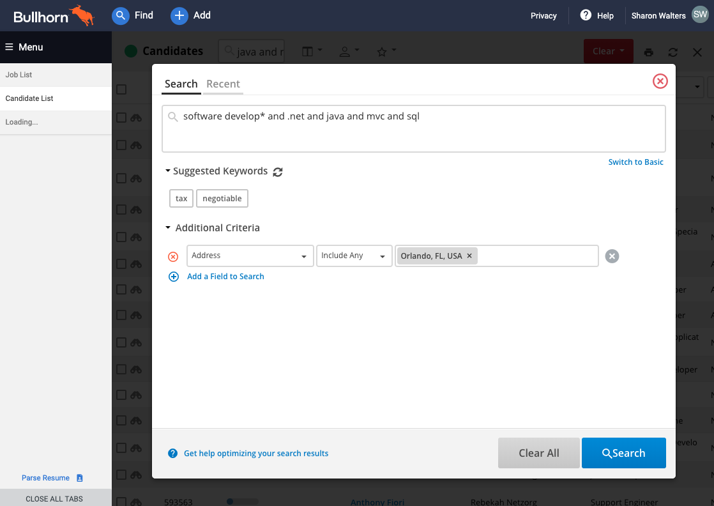

BASIC SEARCH NAVIGATION
In the Basic Search view there are the following sections:

- Keyword Entry
- Only Search Description
- Suggested Keywords
- Additional Criteria

KEYWORD ENTRY
The Keyword Entry field in the Basic Search View is a simpler way to conduct a candidate search. The Boolean operators correlate to the following Basic Search fields:

- Required = AND
- Optional = OR
- Excluded = NOT

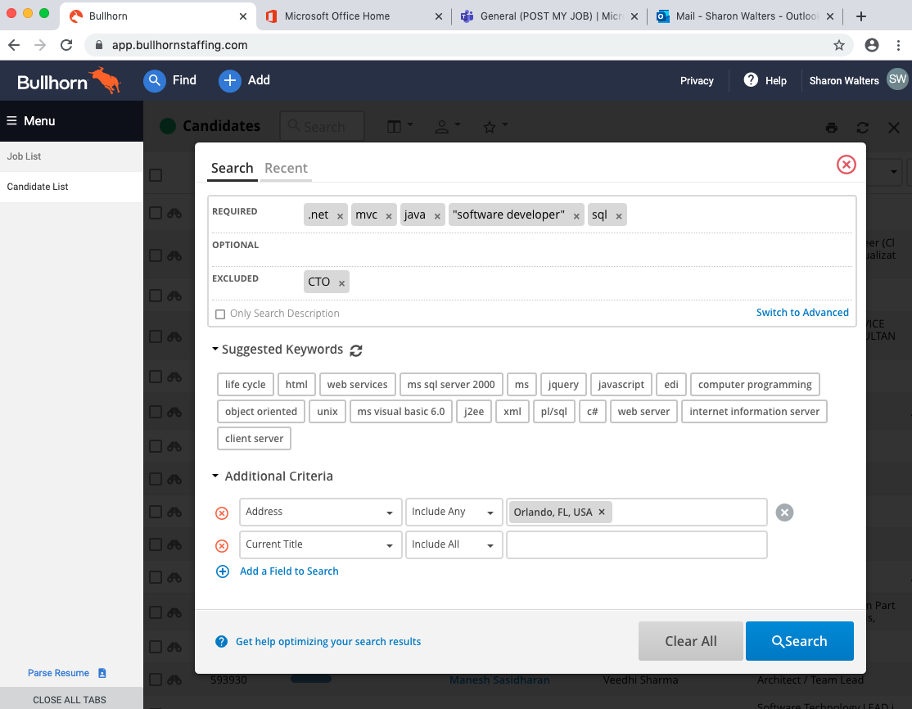

ONLY SEARCH DESCRIPTION
If we select the checkbox to “Only Search Description”, this would ignore the default search parameters:

- ID  - Name  - Current Company  - Notice Required | - Current Title  - Resume  - File Attachments

SUGGESTED KEYWORDS
The feature called Suggested keywords feature will populate additional keywords associated with the keywords you have already entered. This allows novice users to develop their search skills and allows expert users a quick way to enter keywords quickly.

You can click on the Refresh icon to continue refining your results as you continue to narrow or widen your Boolean search.

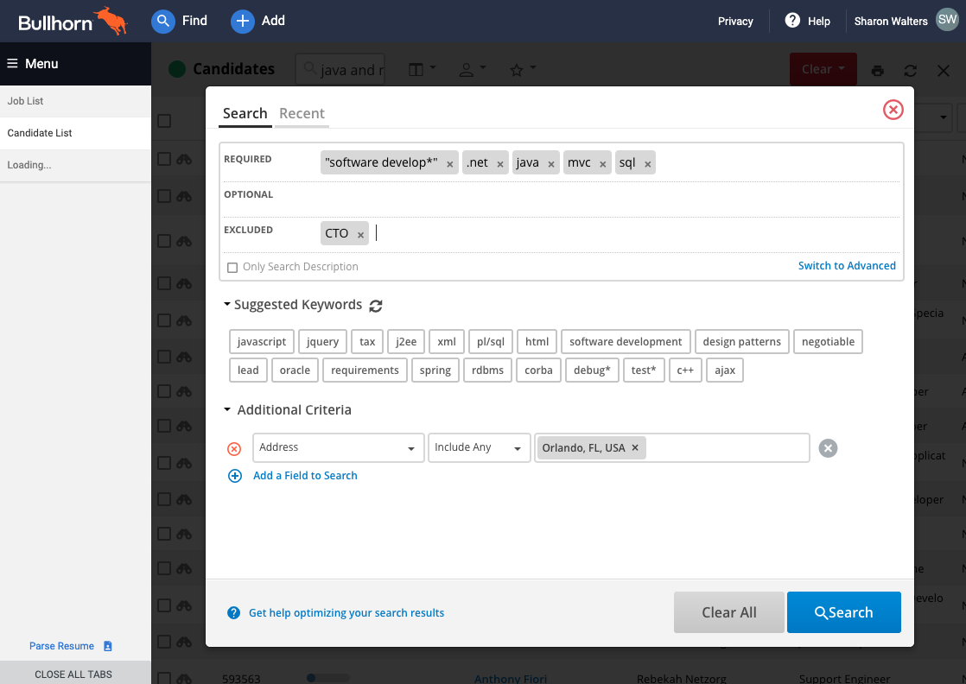

TOGGLING VIEWS BETWEEN ADVANCED AND BASIC
As we switch back to the Advanced View, the keywords added from basic populates back to the Keyword Search field.

The AND’s and OR’s have been removed and replaced with the following characters:

- + (AND) = Required
- Nothing (OR) = Optional
- - (NOT) = Excluded

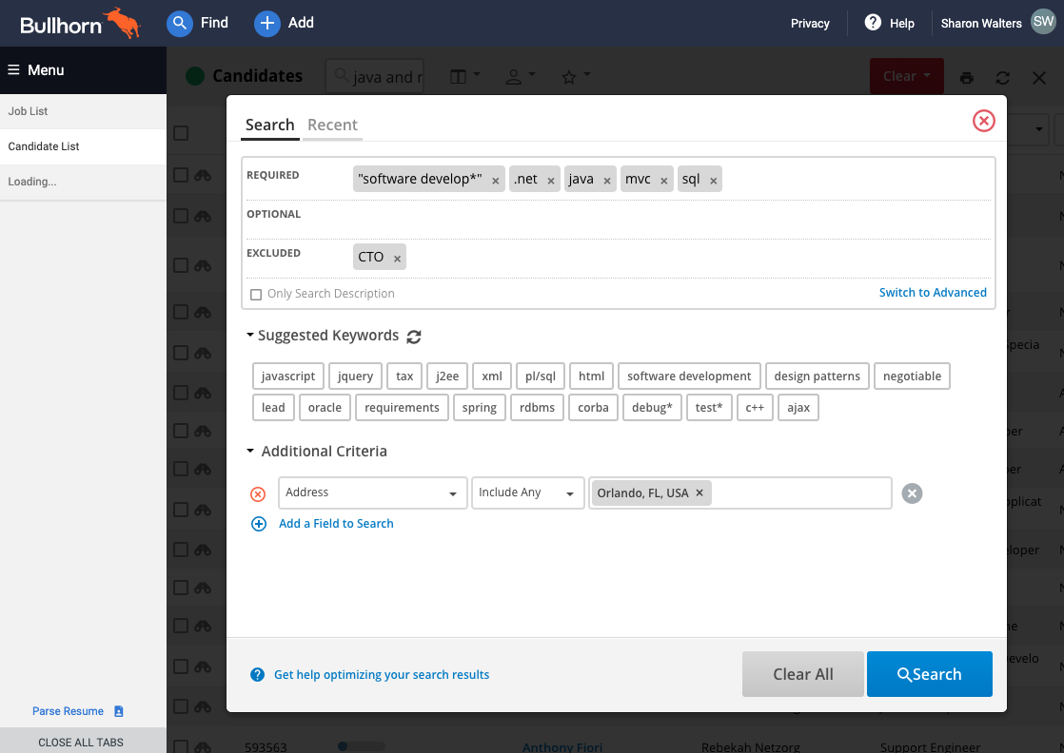

The basic view can quickly identify what keywords are optional and excluded.

If we hit search right now, we can identify through the magnifying glass field where we are searching.

CANDIDATE SEARCH THROUGH JOB ORDERS
You can also do a search directly from within the job order. Once the job order is open:
- Click on Actions
- Click on Find Matching Candidates

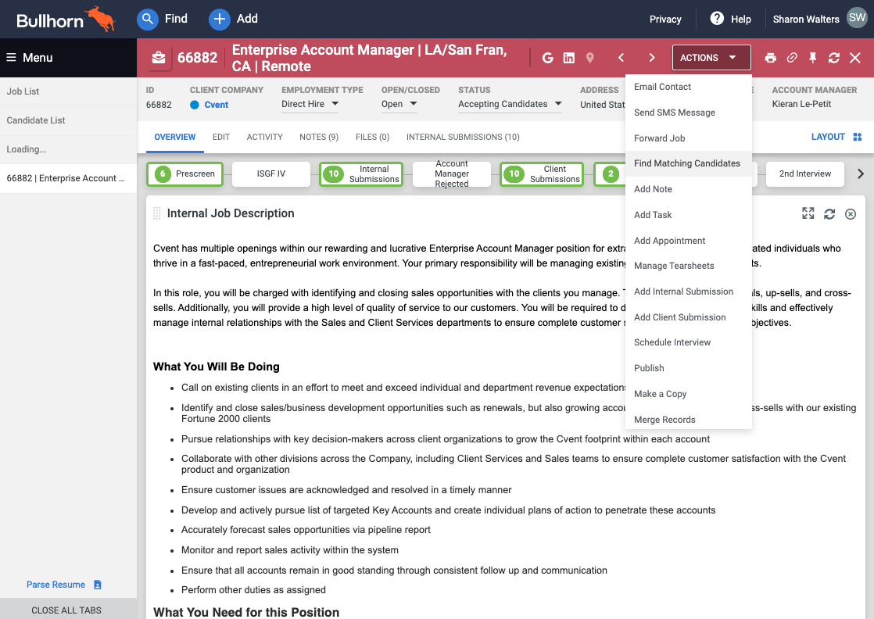

You’ll notice in your Search field on your Candidate List Results there are keywords populated.

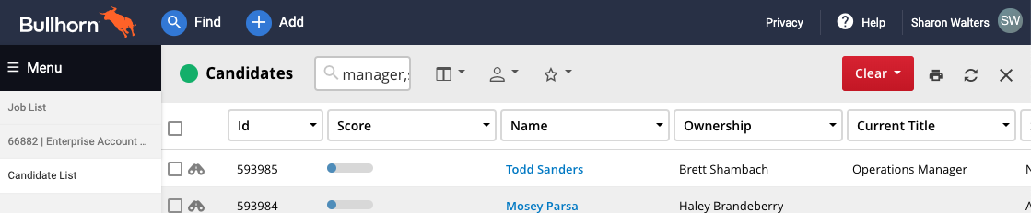

When you click on the Search field, you’ll notice keywords were automatically populated based on common keywords associated with the job description of the job order. You can refine your search as necessary to generate your desired results.

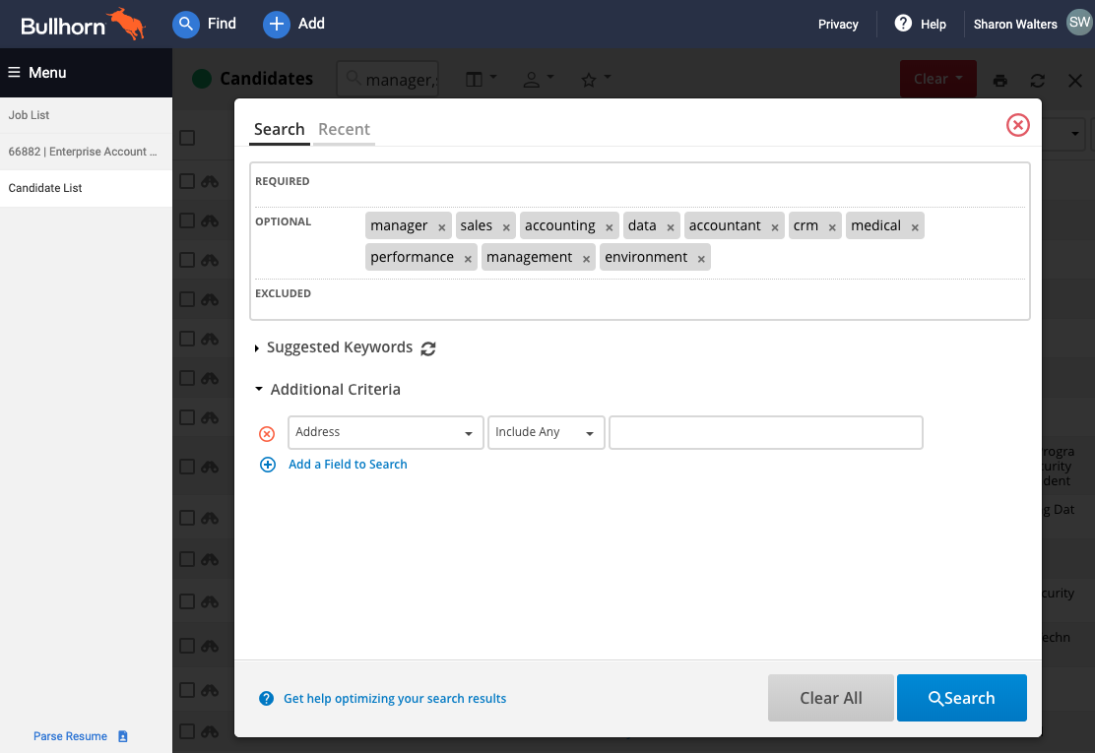

SAVING YOUR SEARCH
If you want to save your search results you can easily save your search requirements by clicking on the Star in your Candidate Navigation Pane.

